Part 1 MiniProject tasks

Paynet.

Wendy Sanjaya

SOFTWARE/ APPLICATION USED IN THIS PROJECT

JDK - java version "1.8.0_261"

Visual Studio Code – Version 1.49.1

Postman

Code template built @ : <https://start.spring.io/>

Maven Project

Java

Spring Boot 2.3.4

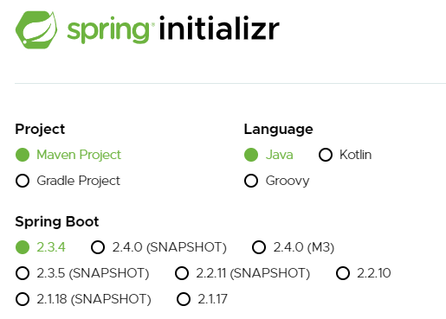

Embedded Tomcat. (No deployment – run via command prompt)

Dependencies (reference to pom.xml)

Source reference during project development:

<https://github.com/eugenp/tutorials/tree/master/core-java-modules/core-java-security-2/src/main/java/com/baeldung/checksums>

<https://examples.javacodegeeks.com/core-java/crypto/encrypt-decrypt-string-with-des/>

**Prepare an overall project documentation with details on**

**·       Specific software versions used (Java SE JDK versions). If possible, use the latest versions of either Java 8 or 11.**

**·       Specific application / web server used (Glassfish, Wildfly, Tomcat, etc) and its version. Include information on any project-specific configuration settings necessary to run the project correctly.**

**·       The IDE used to develop the project (Eclipse JEE, IntelliJ IDEA or Netbeans) and its version**

**·       If you are running the project from within the IDE by linking the application / web server to the IDE, provide specific instructions on how to do this, including all necessary configuration settings for the IDE as well as the JDK and application / web server, if appropriate**

**·       If you are running the project from the application / web server, provide specific instructions how to do this (for e.g. running from an Ant or Maven build), including all necessary configuration settings**

**·       How to test your REST and SOAP API (for e.g. using a client that you have developed or external tools like Postman). The test should incorporate the necessary security mechanisms described in Section 3.4.**

**This documentation will be used by the project evaluator in setting up the appropriate environment on her local machine to run your project. Thus, if the documentation is lacking or inadequate, she may not able to execute and test your project successfully and provide a fair assessment for you.**

Test via POSTMAN

GET

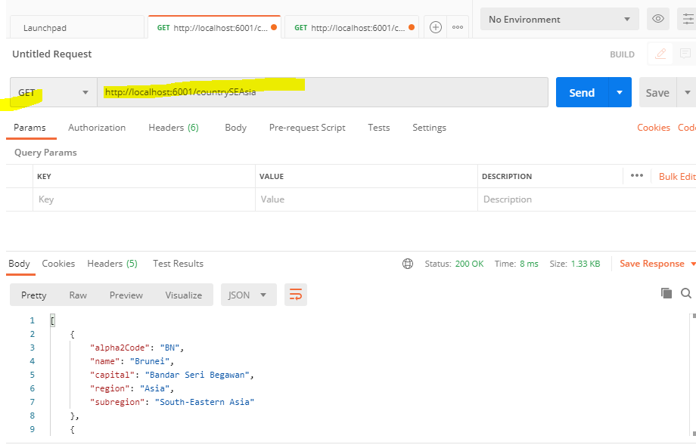

POST

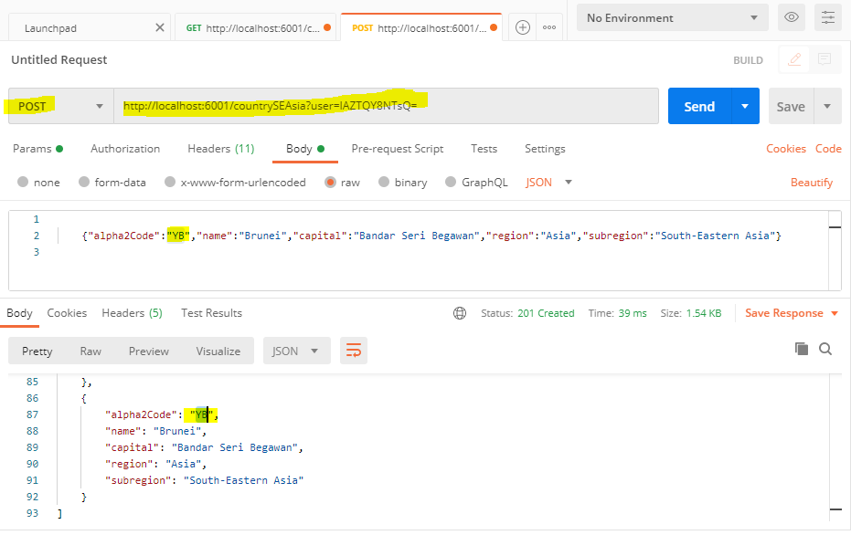

HOW TO RUN -> via. CMD

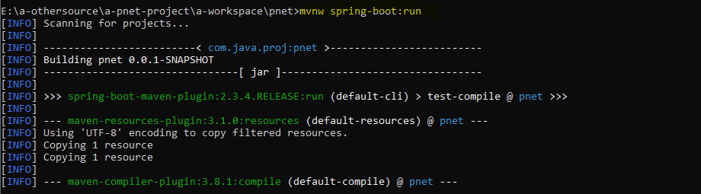

TEST VIA WEB

LANDING PAGE

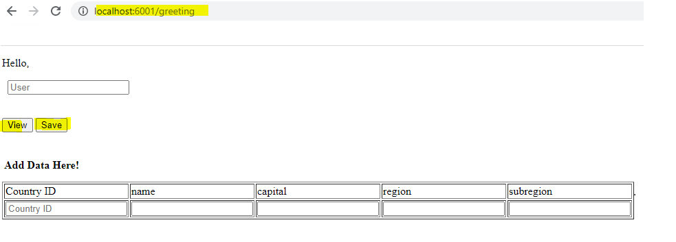

GET (CONSUME DATA FROM EXTERNAL API)

BUTTON: “VIEW”

Class reference: PnetApplication

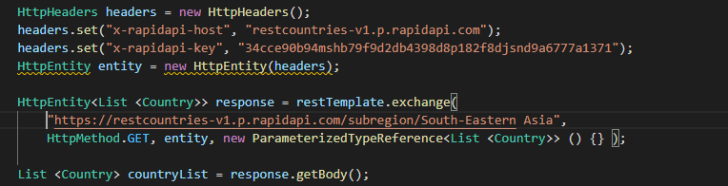

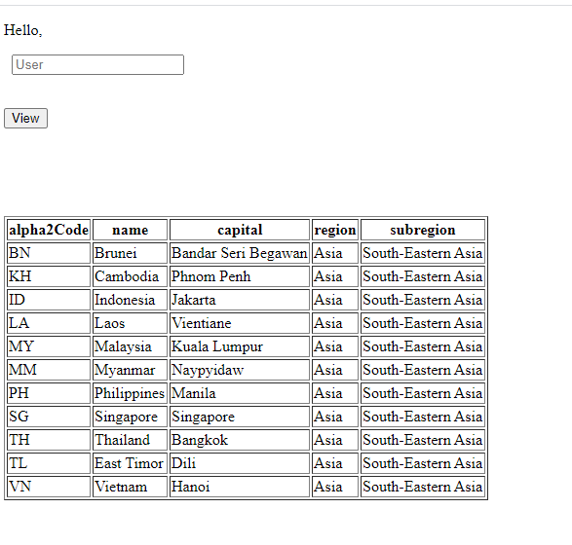

POST

BUTTON: “SAVE”

SAVE DATA INTO DB

ENCRYPT DECRYPT URL PARAM (USER)

SAVE ENTRY TO FILE

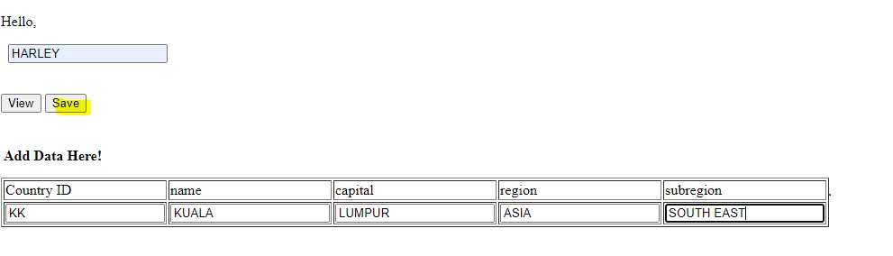

BUTTON: “CHKSUM” after data saved

Add on 02/10/2020: Checksum file path will be defined on properties file.

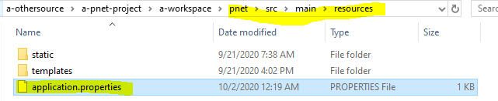

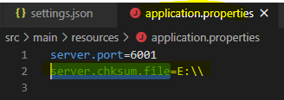

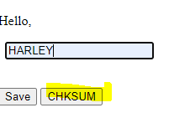

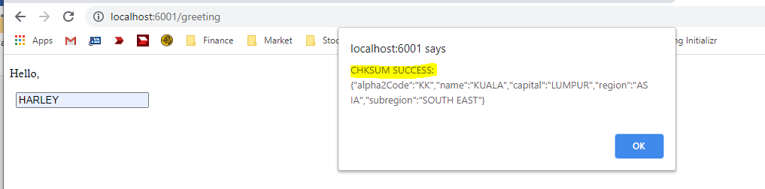

File -> check sum and save form entry.



NEW DATA SAVED – AVAILABLE WHEN “VIEW”

